


学 士 学 位 论 文

论文题目 | Development of a Web-Based House Rental Management SysteM
学生姓名 | SHOFA YASMIN FAUZIAH
专业 | 计算机科学
班级 | 2251520114C
指导教师 | 罗振

二零××年××月

House Rental Management System
房屋租赁管理系统
Name of Degree | Bachelor of Science and Technology (Computer Science)
Student ID | 2251520112406
Name of Candidate | SHOFA YASMIN FAUZIAH (亚敏)
Name of Supervisor | ENGLISH NAME (罗振)

SHENYANG AEROSPACE UNIVERSITY
APRIL 2026

原 创 性 声 明
ORIGINAL LITERARY WORK DECLARATION
本人郑重声明：所呈交的学位论文是本人在导师的指导下独立完成的。除文中已经注明引用的内容外，本论文不包含其他个人或集体已经发表或撰写过的作品或成果，也不包含本人为获得其他学位而使用过的成果。对本文研究做出重要贡献的个人或集体均已在论文中进行了说明并表示谢意。本声明的法律后果由本人承担。
I do solemnly and sincerely declare that the submitted thesis was independently completed by myself under the guidance of my supervisor. Except for the content already cited in the text, this thesis does not contain any other works or achievements that have been published or written by individuals or groups, nor does it include any achievements that I have used to obtain other degrees. Individuals or groups who have made significant contributions to this study have been introduced and expressed gratitude in the thesis. I am fully aware that if in the course of making this Work, I have infringed any copyright whether intentionally or otherwise, I may be subject to legal action or any other action as may be determined by SAU.
论文作者签名: 日期：
Candidate’s Signature Date

指导教师签名: 日期：
Supervisor’s Signature Date

摘 要
许多本地租房市场的房屋租赁业务仍然受到信息管理不规范以及主观决策过程的影响，从而降低了服务质量与交易透明度。已有研究表明，基于 Web 的租赁平台能够简化租房搜索流程，并提高潜在租户的服务效率（Monteverde et al., 2023；Wahab et al., 2025），而在线租赁管理系统则旨在优化租赁相关的行政管理任务（Obse, 2025）。基于上述研究空缺，本研究采用 Laravel 与 MySQL 开发了一套基于 Web 的房屋租赁管理系统，用于在统一工作流程中整合房源管理、租赁申请处理、付款确认、合同生成、合同续租以及租户与中介之间的上下文消息通信功能。

该系统采用基于角色的访问控制机制（管理员、房产中介、租户）、基于状态的交易流程、记录锁定机制以及付款到期自动失效机制，以减少数据冲突与重复租赁风险。此类控制机制与已有研究结论一致，即访问控制仍然是 Web 应用中的关键安全问题（Le et al., 2022）。本研究采用基于 Web 的系统开发方法，并通过功能测试与场景测试对核心模块进行验证。研究结果表明，该系统能够提升租赁交易过程中的可追溯性、数据一致性以及运营监控能力，同时为决策支持与未来的数据分析报告提供结构化数据基础。

关键词：房屋租赁系统1；房产管理2；租赁交易3；数据分析4; Web 应用程序5

Abstract
House rental operations in many local markets are still affected by unstructured information and subjective decision processes, which can reduce service quality and transaction clarity (Setiawan et al., 2026). Prior studies show that web-based rental platforms can simplify rental search and improve service speed for prospective tenants (Monteverde et al., 2023; Wahab et al., 2025), while online rental management systems are intended to streamline administrative rental tasks (Obse, 2025). Based on this gap, this research develops a web-based house rental management system using Laravel and MySQL to integrate property listing, rental request handling, payment confirmation, contract generation, contract extension, and contextual tenant-agent messaging in one workflow. The system applies role-based access control (admin, agent, tenant), status-based transaction flow, record locking, and payment due-date expiration to reduce conflicting updates and duplicate booking risk. This control focus is aligned with findings that access control remains a critical security issue in web applications (Le et al., 2022). Using a web-based system development approach, implementation is validated through functional and scenario-based testing of key modules. The result is an integrated platform that improves traceability, data consistency, and operational monitoring of rental transactions, while providing structured data for decision support and future analytical reporting.
Key Words: House Rental System；Property Management； Rental Transaction； Data Analyst; Web Application

TABLE OF CONTENTS
摘 要 I
Abstract II
1 Chapter 1 Introduction 1
1.1 Background 1
1.2 Problem Statement 2
1.3 Research Objectives 3
1.4 Scope and Limitations 3
1.5 Benefits of the Study 4
2 Chapter 2 Literature Review 5
2.1 House Rental Management Systems 5
2.2 Web-Based Information System Development 5
2.3 Rental Transactions and Property Platform Dynamics 6
2.4 Role-Based Access Control in Web Applications 6
2.5 Data Analysis and Decision Support in Rental Systems 7
2.6 Iterative Prototyping in Rental System Development 7
2.7 Research Gap and Positioning 8
3 Chapter 3 Research Method and Development Methodology 10
3.1 Research Method 10
3.2 Data Collection Technique 11
3.3 Development Methodology 13
3.3.1 Iterative Prototyping 14
3.3.2 Development Stages 16
3.4 Chapter Summary 18
4 Chapter 4 System Analysis and Design 19
4.1 System Overview 19
4.2 Functional Requirements 20
4.2.1 Tenant Requirements 20
4.2.2 Agent Requirements 21
4.2.3 Admin Requirements 22
4.2.4 System Requirements 23
4.3 Non-Functional Requirements 24
4.4 System Architecture 25
4.5 Use Case Diagram and Explanation 26
4.6 Activity Diagram and Explanantion 27
4.6.1 Authentication and Authorization Flow 28
4.6.2 Property management Flow 29
4.6.3 Rental request Flow 30
4.6.4 Payment Transaction 31
4.6.5 Contract and extension Flow 32
4.6.6 Tenant-Agent Messaging Flow 33
4.6.7 Admin Dashboard and Monitoring Flow 34
4.6.8 Homepage and Navigation Flow 35
4.6.9 My Profile Flow 36
4.6.10 Logout Flow 37
4.6.11 Login Activity Logging Flow 38
4.7 State Diagram and Explanation 39
4.8 Database Design 40
4.8.1 Entity Relationship Diagram (ERD) 42
4.8.2 Database Table Structures 43
5 Chapter 5 Implementation and Testing 55
5.1 Development Environment 55
5.2 Homepage and Navigation Module 55
5.3 Authentication and Authorization Module 55
6 Chapter 6 Results and Discussion 56
Conclusion and Suggestion 57
Appendix Ⅰ Title 58
References 59
Acknowledgements 61

- Chapter 1 Introduction
Chapter 1 provides the introductory foundation of this study on a web-based house rental management system. It outlines the current challenges in rental operations, including fragmented data handling, inconsistent transaction tracking, and limited process control across stakeholders. This chapter also presents the research problem formulation, objectives, scope and limitations, and expected benefits as the basis for the subsequent chapters.
  - Background
House rental activities involve repeated interactions among tenants, property owners/agents, and administrators, including listing publication, request handling, payment confirmation, and contract administration. In many local contexts, rental operations still rely on fragmented channels and manually coordinated records, which reduce process consistency and make transaction monitoring difficult (Obse, 2025; Setiawan et al., 2026).
Prior web-based rental studies indicate that digital rental platforms can simplify search processes, accelerate customer service, and provide clearer property information for prospective tenants (Monteverde et al., 2023; Wahab et al., 2025). However, many implementations remain focused on search or basic booking features and do not yet provide tightly controlled end-to-end transaction states.

From a system security and control perspective, access control remains a critical issue in web applications, especially when policies are weakly documented or inconsistently implemented (Le et al., 2022). For rental transactions, this implies the need for clear role boundaries and explicit state transitions to prevent conflicting actions and improve accountability.
Based on these gaps, this research develops a Laravel-based web application that integrates property management, rental request workflow, payment confirmation, contract generation, contract extension, and contextual communication in one controlled rental lifecycle.
  - Problem Statement
This study addresses the following research questions:
- How can a web-based system integrate listing, request, payment, and contract processes into one consistent rental workflow?
- How can the system reduce process conflicts and inconsistent status updates during rental transactions?
- How can role-based access improve control, accountability, and protection against unauthorized actions?
- How can integrated rental data support more transparent operational monitoring and decision support?
  - Research Objectives
The objectives of this study are:
- To design and implement an integrated web-based house rental management system.
- To implement status-based transaction control for rental requests, payment handling, and contract flow.
- To enforce role-based access for admin, agent, and tenant operations.
- To improve data traceability and operational visibility for rental process monitoring.
  - Scope and Limitations
This study is limited to:
- Residential house rental operations with three user roles: admin, agent, and tenant.
- Web-based workflow implementation for listing, request, payment confirmation, and contract administration.
- Internal transaction status processing and due-date validation without direct integration to external payment gateways.
- Application-level process control and data recording, excluding legal dispute resolution beyond system logs and status history.
  - Benefits of the Study
Expected contributions include:
- Practical contribution: improved consistency and transparency of rental operations.
- Engineering contribution: a controlled rental lifecycle model with role-based authorization and status governance.
- Data contribution: structured operational r

- Chapter 2 Literature Review
Chapter 2 reviews the theoretical and empirical foundations relevant to this study. It discusses web-based rental management systems, role-based access control, rental transaction workflows, and data-oriented decision support in rental platforms. This chapter also identifies the research gap and positions the proposed system within recent studies.
  - House Rental Management Systems
Recent studies show that web-based rental systems improve discoverability, reduce manual coordination, and provide faster rental services for tenants and property owners (Monteverde et al., 2023; Obse, 2025; Wahab et al., 2025). Research has also extended rental systems with structured booking workflows and integrated information architecture to reduce fragmented search and booking processes (Indrayani & Istikomah, 2026; Muharam et al., 2024).
From an engineering perspective, rental platforms increasingly combine property listing, tenant-side filtering, request submission, and transaction monitoring in one interface. This integration is important because unstructured data and subjective manual processes remain common bottlenecks in rental decision-making (Setiawan et al., 2026).

  - Web-Based Information System Development
Web-based information systems are commonly developed through iterative or prototyping-oriented methods when requirements evolve during implementation (Riyanti et al., 2024). In rental contexts, such methods are frequently used to align interface flow, role behavior, and transaction states with real operational needs (Upadhyay et al., 2025; Wang et al., 2026).
In addition, data-driven recommendation features have been introduced to support rental selection quality and decision consistency. A web-based recommendation approach using hierarchical fuzzy axiomatic design demonstrates how multi-criteria decision factors can be operationalized in rental matching workflows (Şenyüzlüler & Baykasoglu, 2024).
  - Rental Transactions and Property Platform Dynamics
Beyond system implementation, property-rental research also highlights platform-level dynamics, including platformization, extraction behavior, and changing relationships between tenants, landlords, and intermediaries (Rogers et al., 2024; Wainwright, 2022). These findings justify the need for transparent transaction states and auditable histories in rental systems.
Short-term rental data studies further show that high-frequency operational data can strengthen evidence-based monitoring and policy analysis (Wang et al., 2024). For this thesis, the implication is that rental transaction records should be structured from the start so they are reusable for operational analytics and decision support.
  - Role-Based Access Control in Web Applications
Role-based access control (RBAC) remains a core requirement in multi-actor web applications. Le et al. (2022) emphasize that broken access control is a major web security issue and that policy inconsistencies are common in poorly documented systems. In house rental platforms, this risk directly affects data confidentiality, authorization boundaries, and transaction integrity across admin, agent, and tenant roles.
Therefore, access control in this research is positioned not only as a login/permission feature but as a process-control mechanism tied to state transitions and role responsibilities.
  - Data Analysis and Decision Support in Rental Systems
Rental decision support research demonstrates that structured criteria and objective ranking models can reduce subjectivity in property selection (Setiawan et al., 2026). This supports the inclusion of analyzable transaction data fields, status histories, and role activity logs in the system data model.
User adoption research in boarding-house rental applications also indicates that user trust, usability, and perceived usefulness influence platform acceptance (Pritalia et al., 2025). Thus, system success is not determined only by feature completeness, but also by clarity of workflow and reliability of user-facing information.
  - Iterative Prototyping in Rental System Development
Methodology selection is a recurring issue in rental-system studies because user workflows and role interactions are often refined during development. Existing studies report that iterative and prototype-driven cycles help teams validate interface behavior and transaction flow earlier in implementation (Monteverde et al., 2023; Obse, 2025).
Monteverde et al. (2023) describe a Rapid Application Development process with a prototype cycle where implementation and evaluation are repeated to improve the rental platform. Obse (2025) similarly applies throwaway prototyping to align design decisions with operational requirements before final system integration. These findings show that in rental platforms, development is often more effective when feedback loops are embedded into the process.
In contrast, waterfall-based implementations are also present in the same domain and provide structured sequential stages from requirements to maintenance (Wahab et al., 2025). However, this model is less flexible when requirement changes emerge during module implementation. Therefore, this thesis positions its development approach closer to iterative prototyping, where modules are built, evaluated, and revised in cycles until functional expectations are met.
  - Research Gap and Positioning
Based on prior studies, three practical gaps remain. First, many rental applications focus on search and booking but provide limited end-to-end transaction control. Second, role and status governance are often discussed separately, while operationally they must be integrated. Third, rental platforms often underutilize transaction records for decision support.
This thesis addresses these gaps by developing a web-based house rental management system that integrates: (1) lifecycle-based rental workflow, (2) role-based authorization, and (3) structured transaction data for operational monitoring and future analytics.
- Chapter 3 Research Method and Development Methodology
Chapter 3 presents the research method and development methodology used in this study. The chapter explains how the study was conducted, how the system requirements were collected, and how the web-based house rental management system was developed through an iterative prototyping approach. This chapter functions as the methodological foundation for the rest of the thesis because it connects the research problem, the data collection process, and the software development strategy into one coherent flow.
  - Research Method
This study uses an applied research approach because the main objective is not only to analyze the rental problem, but also to produce a working software solution that can address it. The research is therefore oriented toward practical system development rather than toward theoretical explanation alone. In this project, the outcome expected from the research is a web-based house rental management system that can improve process consistency, role accountability, and transaction traceability in rental operations.
The method is aligned with research and development practice, where a study begins with problem identification, continues with system analysis and design, proceeds to implementation, and ends with validation of the developed artifact. This approach is suitable for a rental system because the application is intended to support a real operational workflow involving multiple users, changing transaction states, and controlled access boundaries. As a result, the study does not treat the system as a static product, but as an evolving artifact that can be refined through repeated development cycles.
The use of an applied research method is also consistent with prior rental system studies that use prototyping-oriented approaches to support gradual refinement of the system (Monteverde et al., 2023; Obse, 2025; Riyanti et al., 2024). These studies show that rental applications are often more effective when the development process allows feedback and revision during implementation. Based on that context, this thesis adopts a development-oriented research method that is suitable for a web application with role-based workflow control.
In practical terms, the research method provides a structured path from the identification of the rental problem to the production of a final system artifact. It ensures that each stage of the thesis is connected to the actual system being built, so the written documentation remains consistent with the implementation process.
  - Data Collection Technique
The data collection stage was carried out to understand the real needs of the rental system and to define the features that must be included in the application. Because this study is development-based, the collected data is not used only to describe the problem, but also to shape the system requirements and guide the design process. The data collection process is therefore a critical stage that connects the research context with the technical solution.
The techniques used in this study are follows.
- Literature study
Literature study was used to collect theoretical and empirical references related to house rental systems, role-based access control, rental transaction workflows, and iterative development methods. Through this technique, the research can position the proposed system within existing academic work and identify what has already been studied in similar domains. The literature review also helps justify the use of prototyping and role-based design choices in the development of the system.
- Observation
Observation was used to understand the rental workflow that the system must support, including property listing, rental request submission, approval process, payment handling, contract flow, and communication between tenant and agent. This technique is important because it helps capture the sequence of operational activities that occur in rental management. By observing the workflow, the study can determine how the system should behave in real use and which parts of the process require tighter control or clearer structure.
- Document analysis
Document analysis was used to study project materials such as the initial project assignment, the initial project report, the dissertation project assignment, source code structure, migration files, database schema, and feature documentation already prepared in the project folder. This technique helps map the actual implementation context and ensures that the methodology is consistent with the software artifact being developed. It is particularly useful for distinguishing between the initial lecturer-provided requirements, the baseline prototype documented in the project report, and the additional features added during later development.
Together, these techniques support the analysis of user roles, workflow states, and data structures that are needed for the final system design. They also help maintain alignment between the research documentation and the software implementation so that the thesis remains grounded in the real project rather than in abstract assumptions.
  - Development Methodology
The development methodology used in this study is Iterative Prototyping. This method is selected because the system requirements are best validated through repeated refinement cycles. The rental workflow involves multiple roles and several dependent processes, so the application needs to be built step by step and reviewed after each iteration. Instead of waiting until all features are finished before evaluating the system, the prototype approach allows early testing of essential functions and gradual correction of design problems.
This methodology is especially suitable for a house rental management system because changes in one module can affect other modules. For example, adjustments in request handling may affect payment flow, contract generation, or messaging. By developing the system iteratively, the study can reduce the risk of design mismatch, detect workflow problems earlier, and keep the application consistent as it expands.
    - Iterative Prototyping
Iterative Prototyping is a development approach in which a working version of the system is created early and then improved continuously based on evaluation results. In this study, the method is used to develop the rental management system from an initial working prototype into a more complete final version. The development is not described through formal software release numbers; instead, it is described through the evolution of the implemented features and workflow refinements.
The development process began with the project assignment provided by the lecturer, which defined the project category as a software design and implementation project with the title House Rental Management System. The assignment already specified the core requirements, including user login and logout, password changes, profile updates, login activity logging, role-based users, property management, rental requests, transaction tracking, and other related rental functions. The first working prototype was then documented in the initial project report as the baseline implementation of this initial scope.
After the baseline prototype was submitted, the system was further refined through additional development. One later dissertation project assignment introduced the analytics dashboard as an additional formal requirement after it was proposed by the student and approved by the supervisor, while several other enhancements, such as contract extension handling and property availability cycle control, were added during the development process as self-initiated improvements. The role-based access control and status-driven workflow were also refined to improve consistency, traceability, and data integrity across the system. In addition, the transaction information was organized so that rental records could be searched by date, transaction number, property, tenant, or agent, consistent with the project requirements. The approved implementation uses Laravel with a browser/server architecture, so the earlier client/server and Java Swing wording is treated as background specification rather than the final implementation choice.
This approach is supported by previous studies on rental system development and web-based information systems, where prototyping helps developers adjust the system to changing requirements and operational feedback (Monteverde et al., 2023; Obse, 2025; Riyanti et al., 2024). In addition, role-based security requirements and structured workflow control are important in rental applications because incorrect access or inconsistent status transitions can affect data integrity and process reliability (Le et al., 2022; Wahab et al., 2025). These findings indicate that a rental platform benefits from a method that allows repeated correction, especially when the system contains transaction states that must remain consistent.

For this thesis, Iterative Prototyping is preferred over a fully linear model because the system includes several interdependent modules, such as property management, request handling, payment status control, contract generation, contract extension, and messaging. Each module can be built and reviewed before the next refinement is added, which makes the development process more practical and easier to revise. The method also makes it easier to align the thesis narrative with the actual progress of development, since the system evolves through clearly identifiable improvements rather than through a single final implementation step.
    - Development Stages
The development process in this study is divided into the following stages.
- Requirement identification
The system needs were identified from the lecturer-provided project assignment, the rental workflow, and the research references. At this stage, the main user roles and core processes were defined so the development could focus on functions that are directly relevant to the rental management problem. This stage provides the basis for deciding what the system must support and what should be excluded from the scope.
- Initial prototype planning
A preliminary system structure was prepared, including the main modules, role boundaries, and high-level data flow. This stage defines the first version of the system before implementation begins. The planning phase is important because it organizes the application into clear parts and prevents the development process from becoming fragmented.
- Prototype implementation
The first working version of the application was developed based on the identified requirements. The implementation focuses on the core rental functions and the role-based access structure. In this project, the early prototype documented in the initial project report served as the baseline version before the system was expanded with additional modules and refinements.
- Evaluation and revision
Each prototype iteration is reviewed to identify missing functions, unclear flows, or inconsistent status transitions. The prototype is then refined based on the evaluation results. In the current project, this revision stage includes improvements such as the analytics dashboard, contract extension handling, property availability cycle control, and transaction search and reporting support. This stage is the core of the iterative method because it turns feedback into concrete improvements and helps the system move closer to the intended behavior.
- Module integration
After the individual modules are improved, they are integrated into one complete system so the full rental workflow can be executed in sequence. Integration ensures that the modules do not function as separate parts, but instead operate as one coherent application that supports end-to-end rental processing.
- Final preparation
The final prototype is prepared for the implementation and testing stage described in the following chapters. At this point, the system structure, user roles, and data flow are stabilized for documentation and verification. This stage marks the transition from development work to formal evaluation and thesis presentation.
  - Chapter Summary
This chapter explained the research method, data collection techniques, and the development methodology used in the study. The selected approach combines applied research with iterative prototyping so the system can be developed and refined in a controlled way. It also clarifies how the project requirements were gathered and how the system was incrementally built to match the rental workflow. The next chapter presents the system analysis and design based on the method described here.

- Chapter 4 System Analysis and Design
Chapter 4 presents the system analysis and design of the web-based house rental management system. This chapter translates the research method and development approach described in Chapter 3 into a concrete system structure. It explains the system scope, functional and non-functional requirements, architecture, process modeling, database design, and design rationale that guide the implementation of the application.
  - System Overview
The proposed system is a web-based house rental management platform designed to support the rental workflow for three main user roles: tenant, agent, and admin. The system centralizes property information, rental request processing, transaction tracking, contract handling, communication, and monitoring functions into one integrated application. By using a browser/server architecture, the platform allows users to access the system through a web browser without requiring a standalone desktop installation.
From a functional perspective, the system is intended to reduce manual coordination in rental operations and improve the consistency of transaction processing. Tenants can browse properties, submit rental requests, communicate with agents, and view rental-related records. Agents can manage property information, review requests, approve or reject transactions, and handle contract-related activities. Admins can monitor system activities, review transaction data, and supervise platform usage at the system level.
The system also maintains transaction traceability through controlled status transitions, role-based access control, and structured storage of user, property, request, contract, message, and audit data. These characteristics make the application suitable for a rental environment where data consistency, accountability, and workflow clarity are important.
  - Functional Requirements
Functional requirements describe the services and behaviors that the system must provide to support the rental process. In this study, the requirements are derived from the lecturer-provided assignment, the refined dissertation project assignment, the project report baseline, and the current system scope. The requirements are organized by role and system-wide functions so that each actor’s responsibilities are clearly defined.
    - Tenant Requirements
The tenant role represents users who search for properties, submit rental requests, and manage their rental-related activities. The system shall provide the following tenant functions:
- The system shall allow tenants to register and log in to the platform using valid credentials.
- The system shall allow tenants to log out securely after completing their session.
- The system shall allow tenants to update their private information and change their password.
- The system shall allow tenants to browse available properties and view detailed property information.
- The system shall allow tenants to filter properties by relevant criteria such as region, price, area, and layout.
- The system shall allow tenants to view property photos and supporting information before making a decision.
- The system shall allow tenants to submit rental requests for selected properties.
- The system shall allow tenants to track the approval status of their rental requests.
- The system shall allow tenants to communicate with agents through the messaging feature.
- The system shall allow tenants to view and download electronic contracts when the rental process is completed.
- The system shall allow tenants to check rent payment-related information.
- The system shall allow tenants to submit contract extension requests when needed.
    - Agent Requirements
The agent role represents real estate users who manage property records and handle rental decisions. The system shall provide the following agent functions:
- The system shall allow agents to log in and log out securely.
- The system shall allow agents to update their private information and change their password.
- The system shall allow agents to create, modify, and manage property information.
- The system shall allow agents to upload and manage property photos.
- The system shall allow agents to update property availability status, such as to let, rented, and under maintenance.
- The system shall allow agents to review rental requests submitted by tenants.
- The system shall allow agents to approve or reject rental requests.
- The system shall allow agents to manage payment and contract-related processes after request approval.
- The system shall allow agents to handle contract extension requests.
- The system shall allow agents to communicate with tenants through the messaging feature.
- The system shall allow agents to end a rental contract when the rental period is completed or terminated.
    - Admin Requirements
The admin role represents administrative users who supervise the overall operation of the system. The system shall provide the following admin functions:
- The system shall allow admins to log in and log out securely.
- The system shall allow admins to update their private information and change their password.
- The system shall allow admins to manage user access by creating, modifying, or disabling agent and tenant accounts when required.
- The system shall allow admins to monitor rental requests, transactions, properties, and contract records.
- The system shall allow admins to access system-wide dashboard information for operational monitoring.
- The system shall allow admins to review login activity records for audit and traceability purposes.
- The system shall allow admins to search transaction information by date, transaction number, property, tenant, or agent.
    - System Requirements
In addition to role-specific requirements, the system shall provide the following general functions:
- The system shall enforce role-based access control so that each user can only access authorized features.
- The system shall validate input data before storing it in the database.
- The system shall record successful login activity for audit purposes.
- The system shall maintain consistent transaction status transitions across the rental workflow.
- The system shall support structured storage of user, property, request, contract, extension, message, and audit data.
- The system shall provide a browser/server-based interface that can be accessed through a standard web browser.
The functional requirements above form the basis for the process models, architecture, and database design presented in the following sections of this chapter.
  - Non-Functional Requirements
The non-functional requirements include:
- Security
The system shall enforce role-based access control and route-level authorization. Unauthorized status transitions and cross-role actions must be prevented.
- Reliability
The system shall maintain consistent request and transaction states through controlled status transitions and guarded update logic. Rental payment deadline checks shall be processed consistently.
- Usability
The system interface shall provide clear navigation and role-specific features. Core flows such as search, request submission, and approval should be completed with minimal interaction steps.
- Maintainability
The system shall use modular Laravel architecture, separating business logic from presentation components to simplify future maintenance and feature extension.
  - System Architecture
The system follows a web application architecture:
- Presentation layer
The user interface is implemented using Blade templates. Different interfaces are served according to user role and process context.
- Application layer
Business processes are handled by Laravel controllers and services. Input validation, workflow checks, and role authorization are executed at this layer.
- Data layer
Data persistence is handled by a relational MySQL schema. Core entities include users, properties, rental requests, transactions, contracts, extensions, and messaging records.
This study adopts a layered web architecture implemented with Laravel, where the presentation layer is handled by Blade-based interfaces, the application layer is managed through controllers and service/business logic, and the data layer is persisted in a MySQL relational database via Eloquent ORM. This structure aligns with common web-based rental system implementations and iterative development practices reported in prior studies (Obse, 2025; Riyanti et al., 2024), while supporting separation of concerns, maintainability, and stable feature evolution.
  - Use Case Diagram
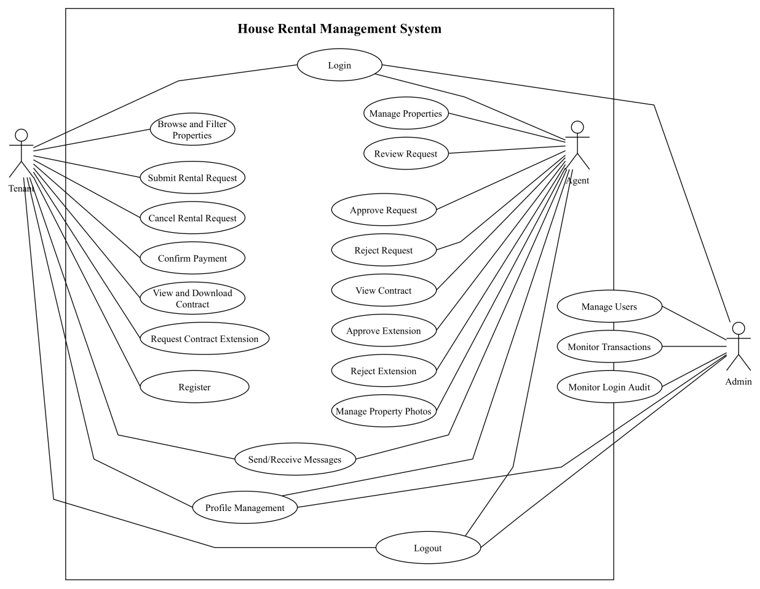
          - Use Case Diagram of House Rental Management System
At use-The use case model describes the interaction between actors and core platform services. Tenant use cases include login, property search, request submission, payment confirmation, contract viewing, extension request, and messaging. Agent use cases include property management, request decision handling, payment validation, extension decision handling, and messaging response. Admin use cases include user and transaction monitoring at platform level. This model confirms that each role is assigned clear responsibilities and access boundaries.
  - Activity Diagram
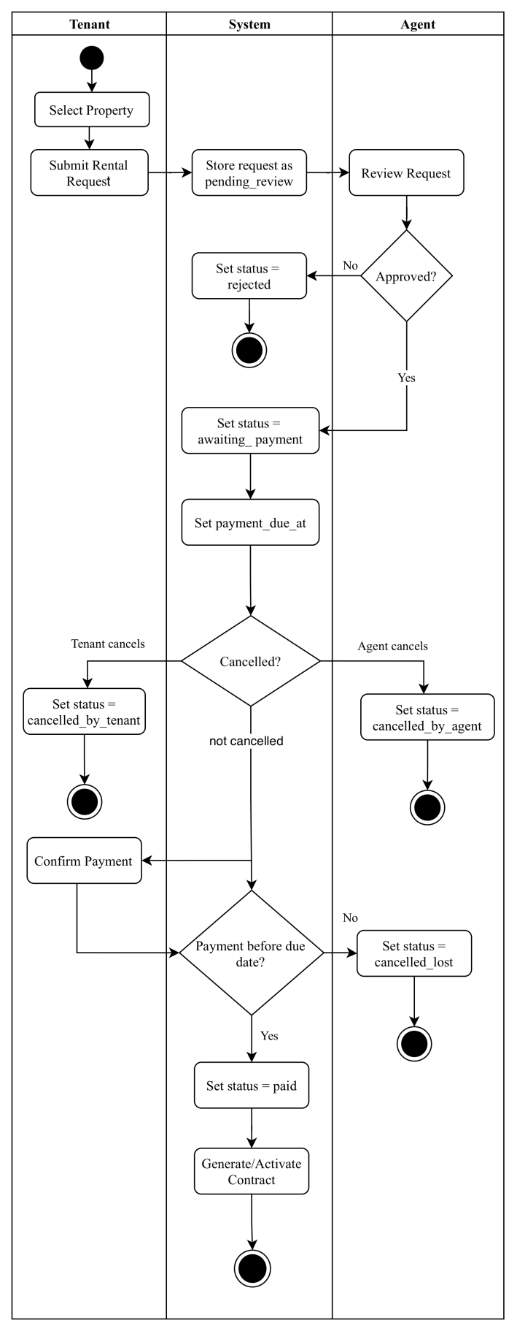
          - Activity Diagram of Rental Request Process
The main activity starts when a tenant selects a property and submits a rental request. The request is recorded with status pending_review. The agent then reviews the request and chooses approval or rejection. If rejected, the flow ends with status rejected. If approved, the system sets status awaiting_payment and creates payment_due_at. The tenant confirms payment, and the system validates due-date constraints. Valid payment changes status to paid and triggers contract activation. Overdue payment changes status to cancelled_lost. This flow prevents conflicting request outcomes and enforces transaction deadlines.
    - Authentication and Authorization Flow
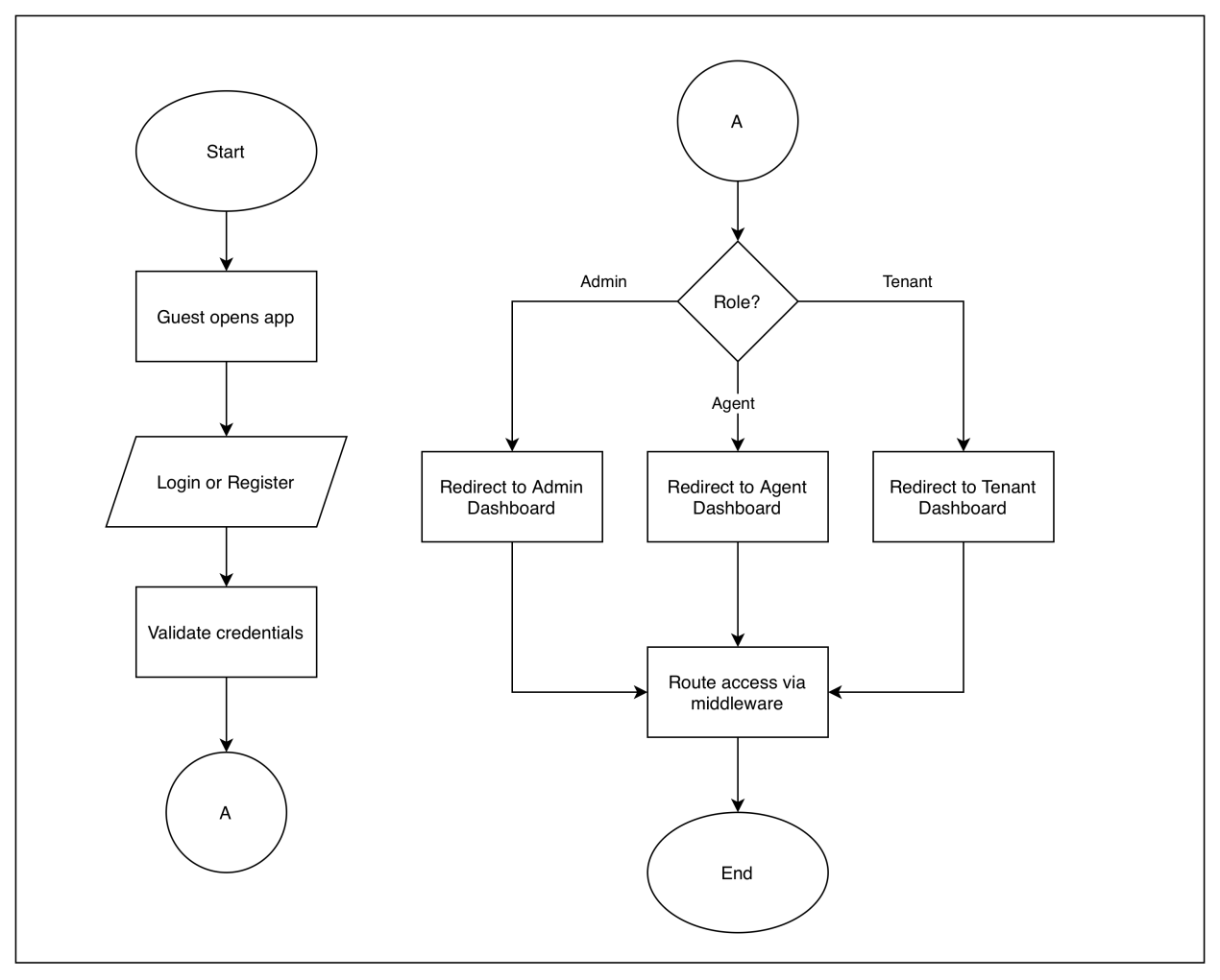
          - Authentication and Role-Based Access Flow
This diagram describes the user authentication process in the system. After login or registration, the system validates the credentials, identifies the user role (admin, agent, or tenant), redirects the user to the appropriate dashboard, and restricts route access through middleware.

    - Property Management Flow
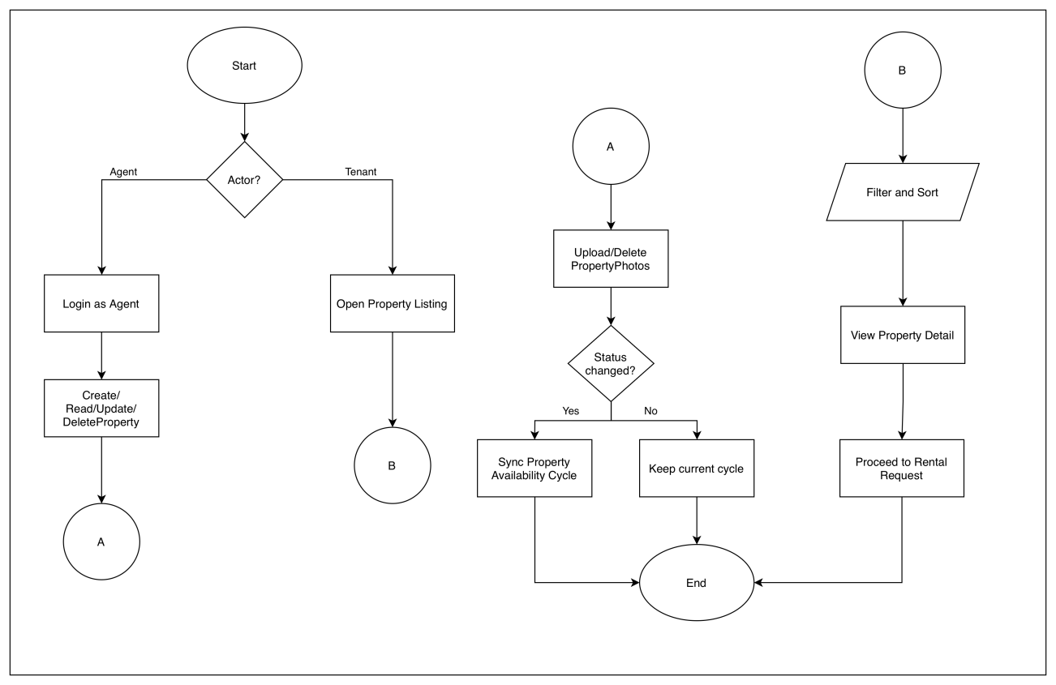
          - Property Management Flow for Agent and Tenant
This diagram shows the two main flows in the property module. For the agent, the flow includes property CRUD operations, photo upload, and property status management. For the tenant, the flow includes browsing listings, filtering and sorting properties, viewing property details, and proceeding to submit a rental request.

    - Rental request Flow
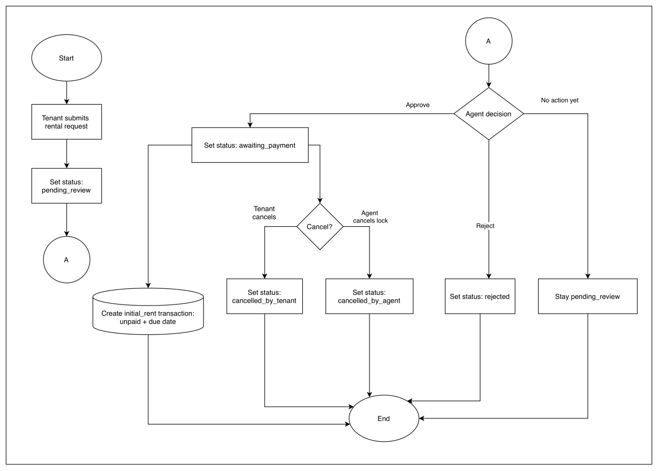
          - Rental Request Lifecycle Flow
This diagram explains the lifecycle of a rental request. The tenant submits a request with the status pending_review, then the agent reviews it and may approve, reject, or cancel the request lock. Each decision leads to a different status update according to the business rules.

    - Payment Transaction
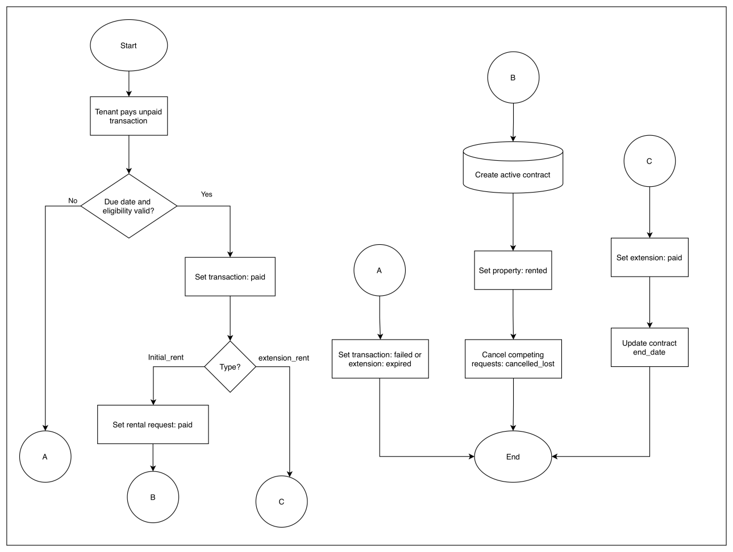
          - Payment Transaction Processing Flow
This diagram illustrates the rental payment process. If the tenant pays before the due date and all conditions are valid, the transaction status changes to paid, the request becomes paid, an active contract is created, and the property status changes to rented. If the payment deadline is missed or the request is no longer eligible, the transaction fails or the extension expires.

    - Contract and extension Flow

          - Contract and Extension Management Flow
This diagram presents the process of contract creation after the initial payment is completed, as well as the contract extension workflow. The tenant may submit an extension request, the agent may approve or reject it, and the tenant pays if the extension is approved. The diagram also includes the manual rental termination process by the agent, which returns the property status to to-let.

    - Tenant-Agent Messaging Flow

          - Tenant-Agent Messaging Flow
This diagram describes the communication flow between tenants and agents through the messaging feature. The system searches for or creates a conversation based on the tenant-agent pair, stores messages with optional property or rental request context, and displays the conversation history to support communication during the rental process.

    - Admin Dashboard and Monitoring Flow
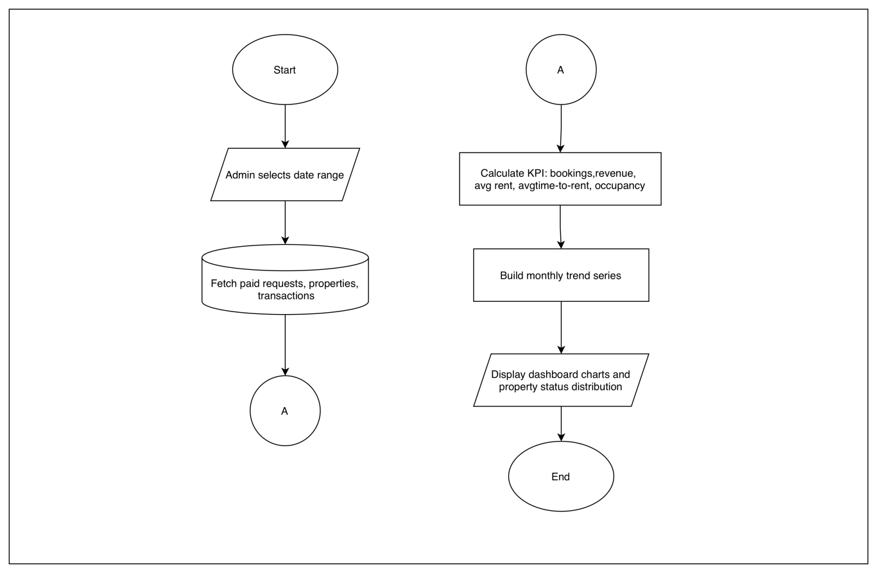
          - Admin Dashboard and Monitoring Flow
This diagram explains how the admin monitors system performance. The admin selects a date range, the system retrieves data from requests, properties, and transactions, and then calculates KPIs such as booking count, revenue, average rent price, average time-to-rent, and occupancy rate. The results are displayed in the dashboard with monthly trends and property status distribution.
    - Homepage and Navigation Flow
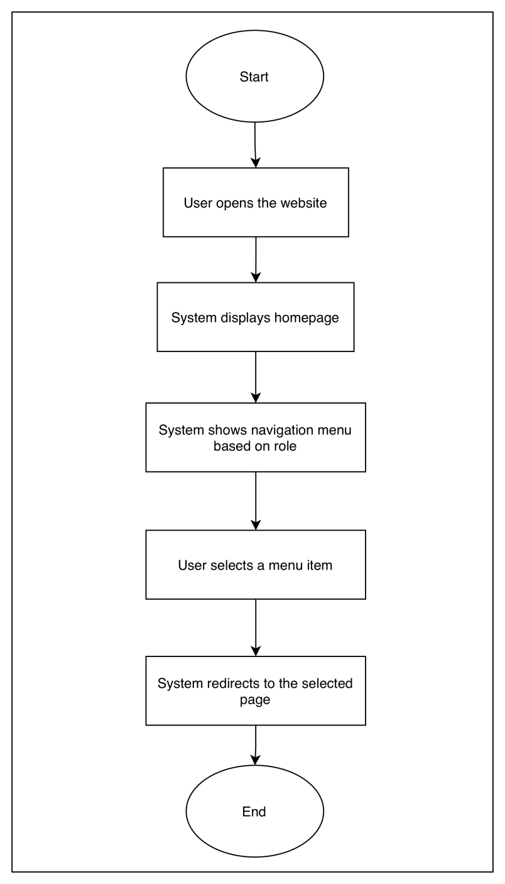
          - Homepage and Navigation Flow
This diagram shows the flow when a user accesses the website, the system displays the homepage, and the navigation menu is shown according to the user role. After that, the user selects a menu item and the system redirects the user to the corresponding page.

    - My Profile Flow
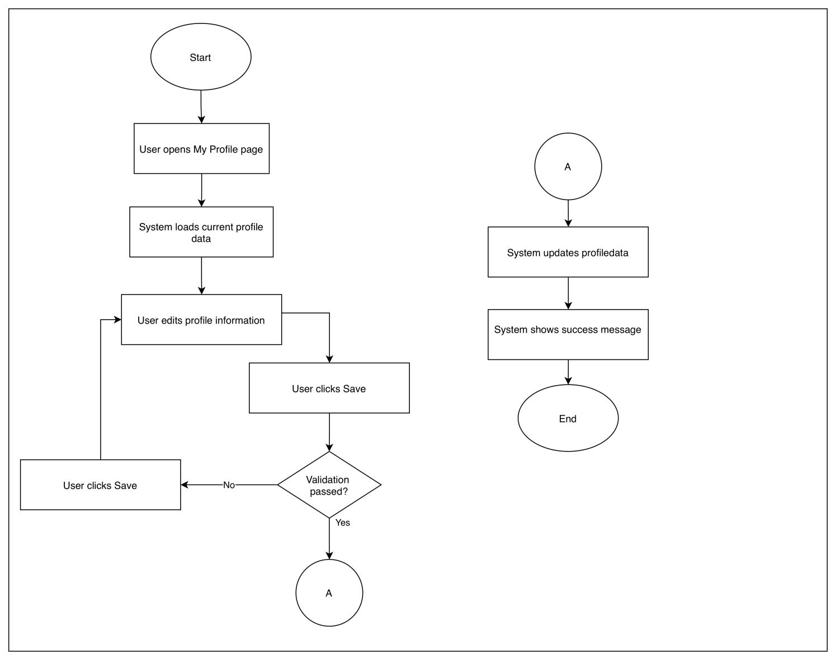
          - My Profile Flow
This diagram illustrates the process of opening the profile page, viewing the stored profile data, editing the information if needed, and saving the updated profile after validation is completed.
    - Logout Flow
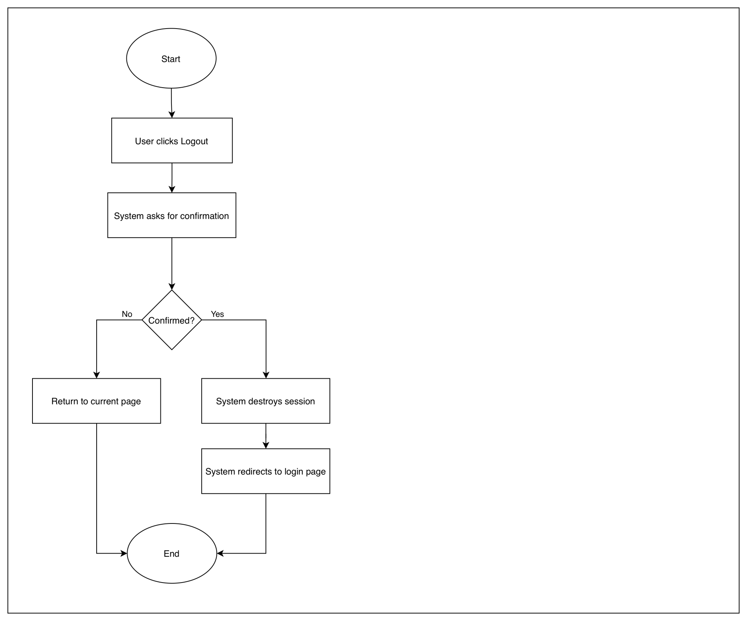
          - Logout Flow
This diagram describes the logout process. When the user selects the logout option, the system ends the active session and redirects the user back to the login page.

    - Login Activity Logging Flow
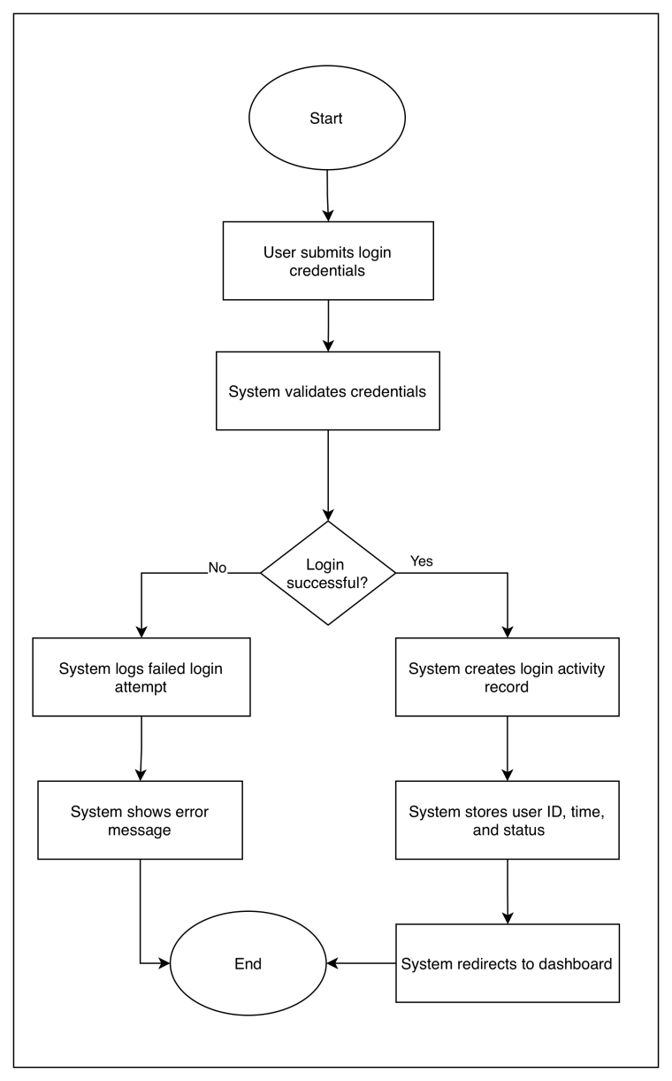
          - Login Activity Logging Flow
This diagram shows how login activity is recorded. When a user attempts to log in, the system validates the credentials and stores the login result, whether successful or failed, in the activity log for monitoring and audit purposes.
  - State Diagram
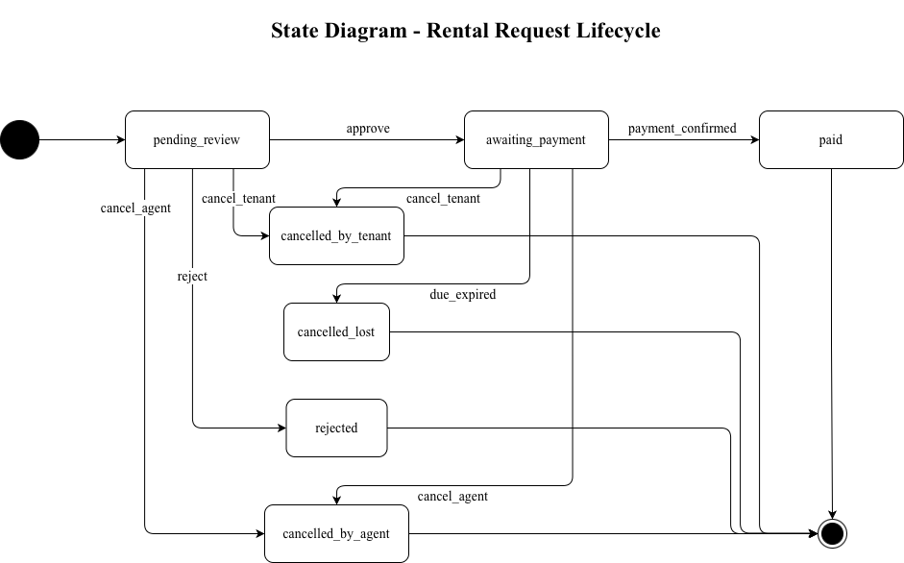
          - State Diagram of Rental Request Lifecycle
This state diagram shows the rental request lifecycle in the system. The process starts when a tenant submits a rental request, and the request enters the pending_review state. In this state, the request is waiting for the agent’s decision.
If the agent approves the request, the state changes to awaiting_payment. The tenant must then complete the payment before the specified due date. When the payment is successfully confirmed, the request changes to the paid state, which indicates that the rental transaction has been completed.
If the agent rejects the request, the request moves to the rejected state and the process ends. The request may also be cancelled by the tenant or the agent. A tenant cancellation changes the state to cancelled_by_tenant, while an agent cancellation changes it to cancelled_by_agent.
The diagram also includes the due_expired transition. If the tenant does not complete the payment within the allowed time, the request changes to cancelled_lost. This transition ensures that expired requests are handled automatically and do not remain active in the system.
Overall, the state diagram defines the valid states and transitions of the rental request process. It helps maintain workflow consistency, prevents conflicting updates, and supports controlled handling of rental transactions from submission to completion or cancellation.
  - Database Design
The database is designed to support user management, property management, rental request processing, transaction handling, contract management, messaging, and audit logging. The main entities are grouped as follows:
No | Functional Group | Tables | Description
 | User and access management | users, login_audit | Stores user account and login audit data
 | Property managemen | properties, property_photos, facilities, property_facility, property_availability_cycles | Stores property records, photos, facilities, and availability cycles
 | Rental workflow | rental_requests, transactions, contracts, contract_extensions | Stores rental requests, transactions, contracts, and extensions
 | Communication | conversations, conversation_messages | Stores conversations and messages
 | Location data | provinces, regencies, districts, villages | Stores province, regency, district, and village data
The database is organized into several functional groups to support the main rental workflow of the system. Each group contains related tables that handle user access, property management, rental processing, communication, and geographic location data. This structure helps maintain data consistency and makes the relationships between entities easier to manage.
These tables are connected through foreign-key constraints to maintain referential integrity across the rental lifecycle. An agent can manage multiple properties, a tenant can submit multiple rental requests, and each request may lead to a transaction and a contract. Communication records are stored through conversations and conversation_messages, while login activity is recorded in login_audit for audit purposes. The inclusion of status fields and availability cycle records helps the system maintain workflow consistency and prevent conflicting updates.
    - Entity Relationship Diagram (ERD)
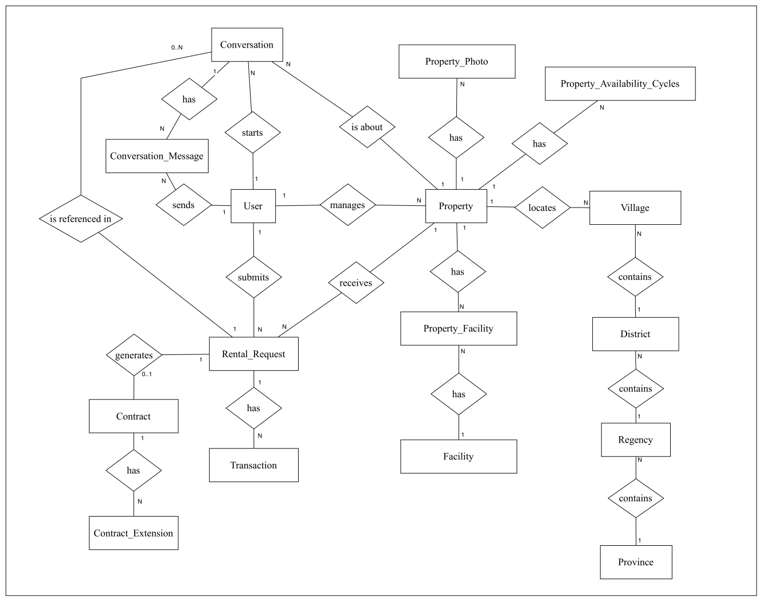
          - Entity Relationship Diagram of the House Rental Management System
Figure 4.15 illustrates the data relationships that support the end-to-end rental workflow. The `users` table represents system actors, where agents manage multiple properties and tenants submit multiple `rental_requests`. Each request is linked to one property and may optionally reference a record in `property_availability_cycles` for time-based availability control. A rental request can generate transaction records and, after successful payment, produce one contract; each contract can then have multiple `contract_extensions`. Communication is modeled through `conversations` and `conversation_messages`, with sender and contextual links to property and rental request data for a traceable discussion history. Property features are modeled using a many-to-many structure between `properties` and `facilities` through `property_facility`, while location data follows a hierarchical structure from `provinces` to `regencies`, `districts`, and `villages`.
    - Database Table Structures
This section presents the physical database structures used in the implementation of the House Rental Management System. Each table is described by field name, data type, attributes, nullability, default value, and business description.
        - User Table
Field | Type | Attributes | Null | Default | Description
id | bigint unsigned | Primary Key, Auto Increment | No | - | User ID
name | varchar(255) | - | No | - | Full name
email | varchar(255) | Unique | No | - | Email address
email_verified_at | timestamp | - | Yes | NULL | Email verification time
password | varchar(255) | - | No | - | Encrypted password
role | enum('admin','agent','tenant') | - | No | tenant | User role
phone | varchar(255) | - | Yes | NULL | Phone number
enabled | tinyint(1) | - | No | 1 | Account status flag
remember_token | varchar(100) | - | Yes | NULL | Remember-me token
created_at | timestamp | - | Yes | NULL | Created time
updated_at | timestamp | - | Yes | NULL | Last updated time
The users table stores account information for all system users, including tenants, agents, and administrators. It contains identity, authentication, contact, role, and status fields used for login, authorization, and account management.
        - Login Audit Table
Field | Type | Attributes | Null | Default | Description
id | bigint unsigned | Primary Key, Auto Increment | No | NULL | Log ID
user_id | bigint unsigned | Foreign Key (users.id) | No | NULL | Logged-in user
ip_address | varchar(45) |  | Yes | NULL | IP address
user_agent | varchar(255) |  | Yes | NULL | Browser / device info
logged_in_at | timestamp |  | No | CURRENT_TIMESTAMP | Login time
The login_audit table stores login activity records for audit and monitoring purposes. Each record is linked to a user account and stores login time, IP address, and browser or device information.
        - Property Table
Field | Type | Attributes | Null | Default | Description
id | bigint unsigned | Primary Key, Auto Increment | No | - | Property ID
agent_id | bigint unsigned | Foreign Key -> users.id | No | - | Property owner/agent
title | varchar(255) | - | No | - | Property title
province_id | bigint unsigned | Foreign Key -> provinces.id | Yes | NULL | Province reference
regency_id | bigint unsigned | Foreign Key -> regencies.id | Yes | NULL | Regency/city reference
district_id | bigint unsigned | Foreign Key -> districts.id | Yes | NULL | District reference
village_id | bigint unsigned | Foreign Key -> villages.id | Yes | NULL | Village reference
address | varchar(255) | - | Yes | NULL | Detailed address
description | text | - | Yes | NULL | Property description
latitude | decimal(10,7) | - | Yes | NULL | Latitude coordinate
longitude | decimal(10,7) | - | Yes | NULL | Longitude coordinate
bedrooms | tinyint unsigned | Indexed | No | 0 | Number of bedrooms
bathrooms | decimal(3,1) | Indexed | No | 1.0 | Number of bathrooms
floors | tinyint unsigned | - | Yes | NULL | Number of floors
area | float | - | Yes | NULL | Land area
building_area | decimal(10,2) | - | Yes | NULL | Building area
facilities | json | Legacy field | Yes | NULL | Legacy facilities payload
rent_price | decimal(12,2) | Indexed | No | - | Rental price
status | enum('to-let','rented','maintenance') | Indexed | No | to-let | Availability status
created_at | timestamp | - | Yes | NULL | Created time
updated_at | timestamp | - | Yes | NULL | Last updated time
The properties table stores the main property information managed by agents. It includes property identity, location, description, pricing, status, and other details required for property listing and rental processing.
        - Property Photo Table
Field | Type | Attributes | Null | Default | Description
id | bigint unsigned | Primary Key, Auto Increment | No | - | Photo ID
property_id | bigint unsigned | Foreign Key -> properties.id | No | - | Related property
path | varchar(255) | - | No | - | Stored file path
created_at | timestamp | - | Yes | NULL | Created time
updated_at | timestamp | - | Yes | NULL | Last updated time
The properties table stores the main property information managed by agents. It includes property identity, location, description, pricing, status, and other details required for property listing and rental processing.

        - Property Availability Cycle Table
Field | Type | Attributes | Null | Default | Description
id | bigint unsigned | Primary Key, Auto Increment | No | - | Cycle ID
property_id | bigint unsigned | Foreign Key -> properties.id | No | - | Related property
available_from_at | timestamp | Indexed (with property_id) | No | - | Start of availability
unavailable_at | timestamp | Indexed (with property_id) | Yes | NULL | End of availability
closed_by | enum('rented','maintenance','manual') | - | Yes | NULL | Reason for closing
created_at | timestamp | - | Yes | NULL | Created time
updated_at | timestamp | - | Yes | NULL | Last updated time
The property_photos table stores image references related to each property. This table supports the display of property photos so that tenants can review visual information before submitting a rental request.
        - Rental Request Table
Field | Type | Attributes | Null | Default | Description
id | bigint unsigned | Primary Key, Auto Increment | No | - | Rental request ID
property_id | bigint unsigned | Foreign Key -> properties.id | No | - | Requested property
availability_cycle_id | bigint unsigned | Foreign Key -> property_availability_cycles.id | Yes | NULL | Bound availability cycle
tenant_id | bigint unsigned | Foreign Key -> users.id | No | - | Requesting tenant
status | enum('pending_review','awaiting_payment','paid','rejected','cancelled_by_tenant','cancelled_by_agent','cancelled_lost') | - | No | pending_review | Request lifecycle status
awaiting_payment_at | timestamp | - | Yes | NULL | Entered awaiting payment at
payment_due_at | timestamp | Indexed | Yes | NULL | Payment due deadline
paid_at | timestamp | - | Yes | NULL | Paid timestamp
rejected_at | timestamp | - | Yes | NULL | Rejected timestamp
cancelled_at | timestamp | - | Yes | NULL | Cancelled timestamp
created_at | timestamp | - | Yes | NULL | Created time
updated_at | timestamp | - | Yes | NULL | Last updated time
id | bigint unsigned | Primary Key, Auto Increment | No | - | Rental request ID
property_id | bigint unsigned | Foreign Key -> properties.id | No | - | Requested property
availability_cycle_id | bigint unsigned | Foreign Key -> property_availability_cycles.id | Yes | NULL | Bound availability cycle
tenant_id | bigint unsigned | Foreign Key -> users.id | No | - | Requesting tenant
status | enum('pending_review','awaiting_payment','paid','rejected','cancelled_by_tenant','cancelled_by_agent','cancelled_lost') | - | No | pending_review | Request lifecycle status
awaiting_payment_at | timestamp | - | Yes | NULL | Entered awaiting payment at
payment_due_at | timestamp | Indexed | Yes | NULL | Payment due deadline
paid_at | timestamp | - | Yes | NULL | Paid timestamp
rejected_at | timestamp | - | Yes | NULL | Rejected timestamp
cancelled_at | timestamp | - | Yes | NULL | Cancelled timestamp
created_at | timestamp | - | Yes | NULL | Created time
updated_at | timestamp | - | Yes | NULL | Last updated time
The rental_requests table stores tenant rental requests for selected properties. It tracks the request status, message, related property, tenant identity, and other workflow-related information used throughout the rental process.
        - Transaction Table
Field | Type | Attributes | Null | Default | Description
id | bigint unsigned | Primary Key, Auto Increment | No | - | Transaction ID
rental_request_id | bigint unsigned | Foreign Key -> rental_requests.id | No | - | Related request
amount | decimal(12,2) | - | No | - | Transaction amount
type | enum('initial_rent','extension_rent') | Unique pair with rental_request_id | No | initial_rent | Transaction type
status | enum('unpaid','paid','failed') | - | No | unpaid | Payment status
property_id | bigint unsigned | Foreign Key -> properties.id | No | - | Related property
tenant_id | bigint unsigned | Foreign Key -> users.id | No | - | Paying tenant
agent_id | bigint unsigned | Foreign Key -> users.id | No | - | Receiving agent
contract_extension_id | bigint unsigned | Foreign Key -> contract_extensions.id | Yes | NULL | Linked extension (if any)
created_at | timestamp | - | Yes | NULL | Created time
updated_at | timestamp | - | Yes | NULL | Last updated time
The transactions table stores rental transaction records that reflect which property is rented by which tenant and at what time. It also supports transaction monitoring, payment-related tracking, and historical reporting.
        - Contract Table
Field | Type | Attributes | Null | Default | Description
id | bigint unsigned | Primary Key, Auto Increment | No | - | Contract ID
rental_request_id | bigint unsigned | Foreign Key -> rental_requests.id, Unique | No | - | Source request
start_date | date | - | No | - | Contract start date
end_date | date | - | No | - | Contract end date
total_price | decimal(12,2) | - | No | - | Total contract value
monthly_rent | decimal(12,2) | - | Yes | NULL | Monthly rent snapshot
status | enum('active','ended') | - | No | active | Contract status
ended_reason | text | - | Yes | NULL | End reason
ended_by | bigint unsigned | Foreign Key -> users.id | Yes | NULL | User who ended contract
ended_at | timestamp | - | Yes | NULL | Contract end timestamp
created_at | timestamp | - | Yes | NULL | Created time
updated_at | timestamp | - | Yes | NULL | Last updated time
The contracts table stores contract records generated after a rental request is successfully processed. It contains contract dates, total price, and contract status information used to manage the rental agreement lifecycle.
        - Contract Extension Table
Field | Type | Attributes | Null | Default | Description
id | bigint unsigned | Primary Key, Auto Increment | No | - | Extension ID
contract_id | bigint unsigned | Foreign Key -> contracts.id | No | - | Parent contract
old_end_date | date | - | No | - | Original end date
new_end_date | date | - | No | - | Proposed end date
extended_at | timestamp | - | No | - | Extension created timestamp
months_requested | int unsigned | - | No | 1 | Number of months requested
monthly_rent_snapshot | decimal(12,2) | - | Yes | NULL | Rent snapshot at request time
amount | decimal(12,2) | - | Yes | NULL | Computed extension amount
status | enum('pending','awaiting_payment','paid','rejected','cancelled_by_tenant','expired') | - | No | pending | Extension status
approved_by | bigint unsigned | Foreign Key -> users.id | Yes | NULL | Approving agent/admin
approved_at | timestamp | - | Yes | NULL | Approval timestamp
payment_due_at | timestamp | Indexed | Yes | NULL | Extension payment due
rejected_at | timestamp | - | Yes | NULL | Rejection timestamp
cancelled_at | timestamp | - | Yes | NULL | Tenant cancellation timestamp
paid_at | timestamp | - | Yes | NULL | Paid timestamp
created_at | timestamp | - | Yes | NULL | Created time
updated_at | timestamp | - | Yes | NULL | Last updated time
The contract_extensions table stores records of contract extension requests and their processing status. It supports extension approval, payment due tracking, and the continuation of rental agreements.
        - Conversation Table
Field | Type | Attributes | Null | Default | Description
id | bigint unsigned | Primary Key, Auto Increment | No | - | Conversation ID
property_id | bigint unsigned | Foreign Key -> properties.id | No | - | Main property context
tenant_id | bigint unsigned | Foreign Key -> users.id | No | - | Tenant participant
agent_id | bigint unsigned | Foreign Key -> users.id | No | - | Agent participant
rental_request_id | bigint unsigned | Foreign Key -> rental_requests.id | Yes | NULL | Optional request context
status | enum('open','closed') | - | No | open | Conversation status
last_message_at | timestamp | - | Yes | NULL | Last message timestamp
created_at | timestamp | - | Yes | NULL | Created time
updated_at | timestamp | - | Yes | NULL | Last updated time
The conversations table stores conversation records between users, especially tenants and agents. It provides the main container for contextual messaging related to a property or rental request.
        - Conversation Message Table
Field | Type | Attributes | Null | Default | Description
id | bigint unsigned | Primary Key, Auto Increment | No | - | Message ID
conversation_id | bigint unsigned | Foreign Key -> conversations.id | No | - | Parent conversation
sender_id | bigint unsigned | Foreign Key -> users.id | No | - | Message sender
property_id | bigint unsigned | Foreign Key -> properties.id | Yes | NULL | Optional property context
rental_request_id | bigint unsigned | Foreign Key -> rental_requests.id | Yes | NULL | Optional request context
message | text | - | No | - | Message content
created_at | timestamp | Indexed with conversation_id | Yes | NULL | Created time
updated_at | timestamp | - | Yes | NULL | Last updated time
The conversation_messages table stores individual messages within each conversation. It records the sender, message content, and contextual references needed to maintain traceable communication history.
        - Facility Table
Field | Type | Attributes | Null | Default | Description
id | bigint unsigned | Primary Key, Auto Increment | No | - | Facility ID
slug | varchar(50) | Unique | No | - | Facility code
name | varchar(100) | - | No | - | Facility name
category | enum('utilities','interior','outdoor') | Indexed | No | - | Facility category
is_active | tinyint(1) | - | No | 1 | Active flag
created_at | timestamp | - | Yes | NULL | Created time
updated_at | timestamp | - | Yes | NULL | Last updated time
The facilities table stores the master list of available property facilities. Each record represents one facility type that can be assigned to one or more properties.
        - Property Facility Pivot Table
Field | Type | Attributes | Null | Default | Description
id | bigint unsigned | Primary Key, Auto Increment | No | - | Pivot record ID
property_id | bigint unsigned | Foreign Key -> properties.id | No | - | Property reference
facility_id | bigint unsigned | Foreign Key -> facilities.id | No | - | Facility reference
value | varchar(100) | - | Yes | NULL | Optional facility value
created_at | timestamp | - | Yes | NULL | Created time
updated_at | timestamp | - | Yes | NULL | Last updated time
The property_facility table stores the many-to-many relationship between properties and facilities. This table links each property to the facilities it provides and allows the system to represent property amenities in a structured way.
        - Province Table
Field | Type | Attributes | Null | Default | Description
id | bigint unsigned | Primary Key, Auto Increment | No | - | Province ID
name | varchar(255) | - | No | - | Province name
code | varchar(20) | Unique | No | - | Province code
created_at | timestamp | - | Yes | NULL | Created time
updated_at | timestamp | - | Yes | NULL | Last updated time
The provinces table stores the master list of provinces used in the location hierarchy. It serves as the top-level geographic reference for property data.
        - Regency Table
Field | Type | Attributes | Null | Default | Description
id | bigint unsigned | Primary Key, Auto Increment | No | - | Regency ID
province_id | bigint unsigned | Foreign Key -> provinces.id, Indexed | No | - | Parent province
name | varchar(255) | - | No | - | Regency name
code | varchar(20) | Unique | No | - | Regency code
created_at | timestamp | - | Yes | NULL | Created time
updated_at | timestamp | - | Yes | NULL | Last updated time
The regencies table stores regency or city data and is linked to the provinces table through a foreign-key relationship. It supports the hierarchical location structure used in property records.
        - District Table
Field | Type | Attributes | Null | Default | Description
id | bigint unsigned | Primary Key, Auto Increment | No | - | District ID
regency_id | bigint unsigned | Foreign Key -> regencies.id, Indexed | No | - | Parent regency
name | varchar(255) | - | No | - | District name
code | varchar(20) | Unique | No | - | District code
created_at | timestamp | - | Yes | NULL | Created time
updated_at | timestamp | - | Yes | NULL | Last updated time
The districts table stores district-level location data and is linked to the regencies table. It helps the system represent more detailed geographic information.
        - Village Table
Field | Type | Attributes | Null | Default | Description
id | bigint unsigned | Primary Key, Auto Increment | No | - | Village ID
district_id | bigint unsigned | Foreign Key -> districts.id, Indexed | No | - | Parent district
name | varchar(255) | - | No | - | Village name
code | varchar(20) | Unique | No | - | Village code
created_at | timestamp | - | Yes | NULL | Created time
updated_at | timestamp | - | Yes | NULL | Last updated time

The villages table stores village-level location data and is linked to the districts table. It provides the most detailed location reference used in the system.

- Chapter 5 Implementation and Testing
Chapter 5 presents the implementation of the web-based house rental management system and the testing approach used to verify the implemented functions. This chapter explains how the system was developed in the Laravel framework, how each major module was realized in the application, and how the implemented features were validated through functional and workflow-based testing.
  - Development Environment
The system was implemented as a web-based application using Laravel and MySQL in a browser/server architecture. Development was carried out in a local environment using role-based user accounts, namely tenant, agent, and admin. This setup allows the system to be developed and tested in a controlled environment before deployment.
Laravel is used as the main application framework because it supports modular development through controllers, routes, models, middleware, and request validation. MySQL is used as the relational database management system to store user data, property records, rental requests, transactions, contracts, contract extensions, messages, login audit records, and location data. The combination of Laravel and MySQL provides a stable structure for handling the core rental workflow and maintaining data consistency across related modules.
The development environment also supports iterative implementation and testing of the system modules. Each module can be developed independently, verified through functional testing, and then integrated into the complete application. This environment is suitable for a rental management system because it supports role-based access control, transactional workflow management, and structured data storage within one integrated platform.
  - Implementation of System Functions
This section presents the main features implemented in the House Rental Management System. Each feature corresponds to the functional requirements and process models described in the previous chapters. The implementation is organized according to the main user interactions and system modules so that the overall application flow can be understood clearly.
    - Homepage and Navigation Module
The homepage serves as the public entry point to the system. It provides access to property browsing and the authentication pages, allowing visitors and tenants to begin using the platform without requiring any prior navigation steps. The homepage also presents the primary navigation structure that directs users to the appropriate section based on their role.
The navigation design is role-aware. Tenants are directed to browsing, request, contract, message, and profile functions. Agents are directed to property management, request review, contract handling, photo management, and messaging. Admins are directed to user monitoring, transaction monitoring, and login audit pages. This structure ensures that users can access the relevant features with minimal interaction.
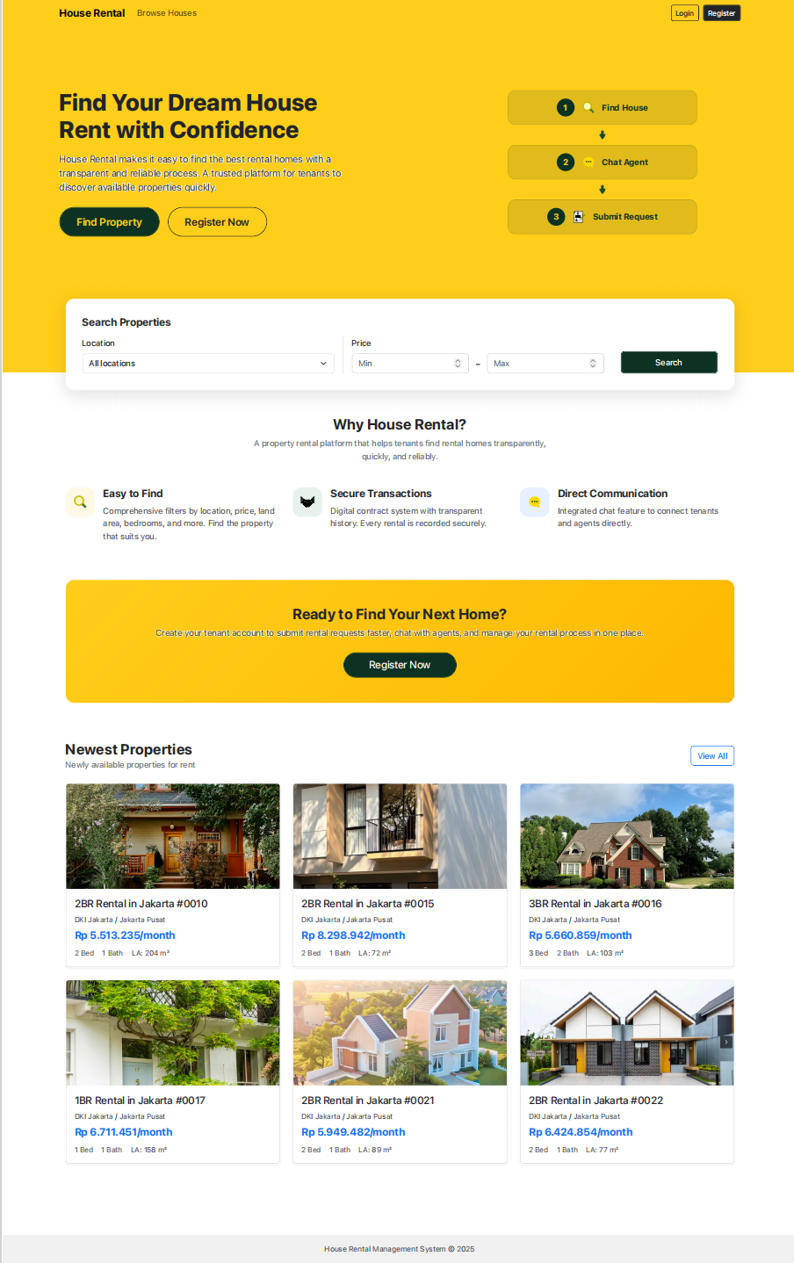
          - Homepage and Navigation Interface
    - Authentication and Authorization Module
Authentication is implemented through the Laravel session-based login mechanism. Users provide their email and password, and the system validates the credentials before creating an authenticated session. After login, the system identifies the user role and redirects the user to the appropriate dashboard.
Authorization is enforced through middleware and role checks. Each user can only access the features assigned to their role, which prevents unauthorized access to protected pages. The system also supports secure logout by destroying the active session and redirecting the user back to the login page. In addition, user registration is provided for new tenant accounts.
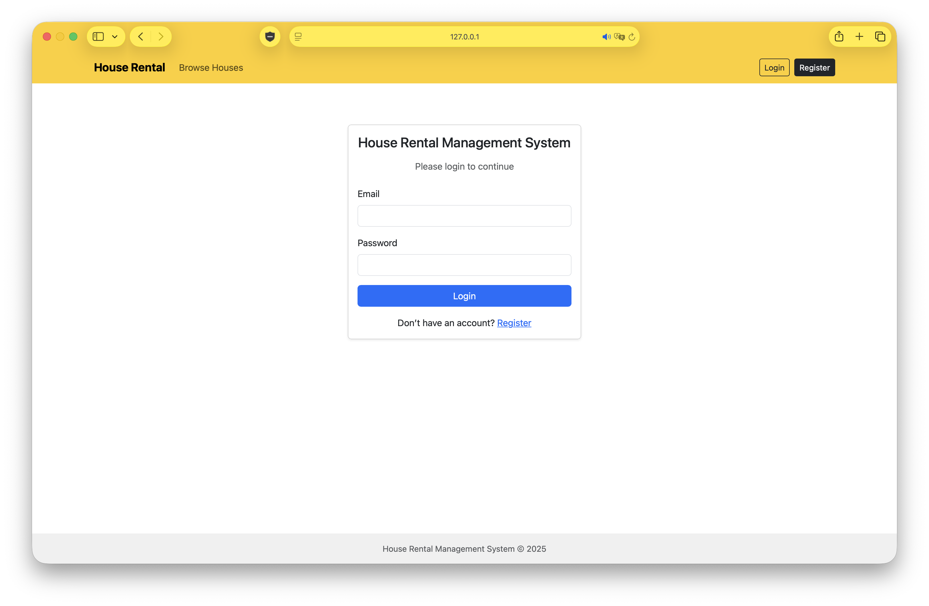
          - Login Interface
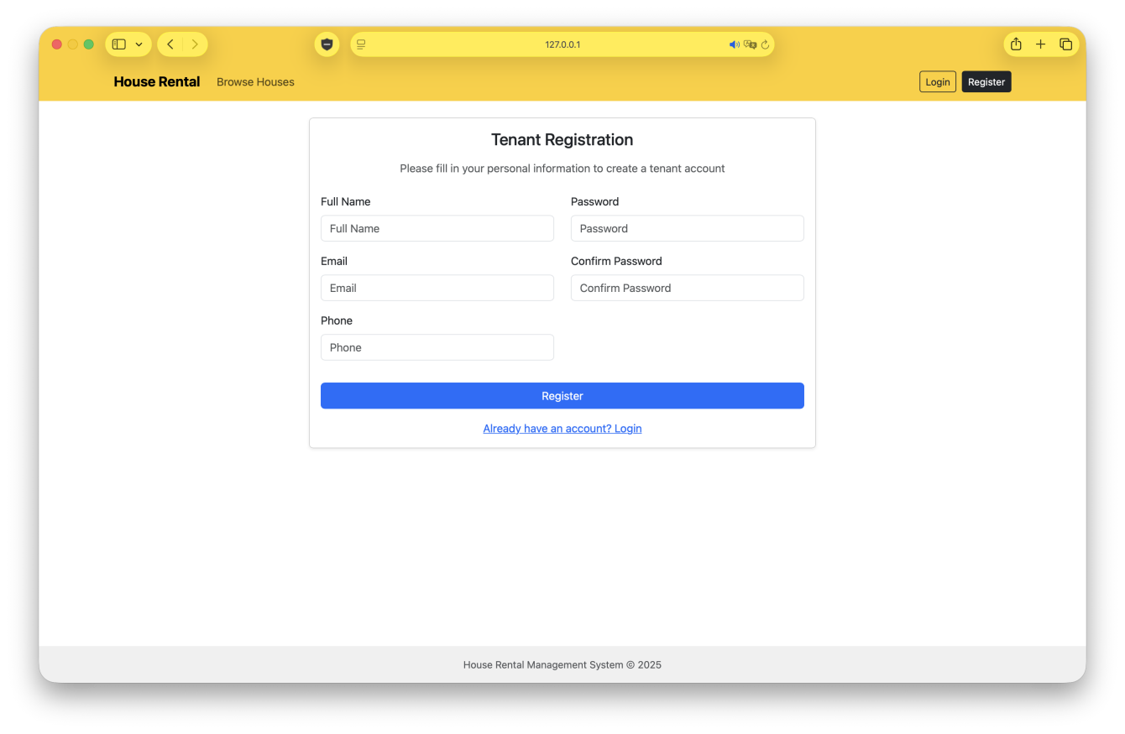
          - Register Interface
    - Property Management
The property management module is used by agents to create, edit, view, and delete property records. Each property record contains essential information such as title, address, location, rental price, description, room details, and current status. The module also supports the management of property photos so that tenants can review visual information before submitting a rental request.
The system allows agents to update property availability status to reflect whether a property is to let, rented, or under maintenance. Location data is linked through hierarchical references so that property records can be filtered and displayed consistently according to geographic area. This module provides the data foundation for the property browsing functions used by tenants.
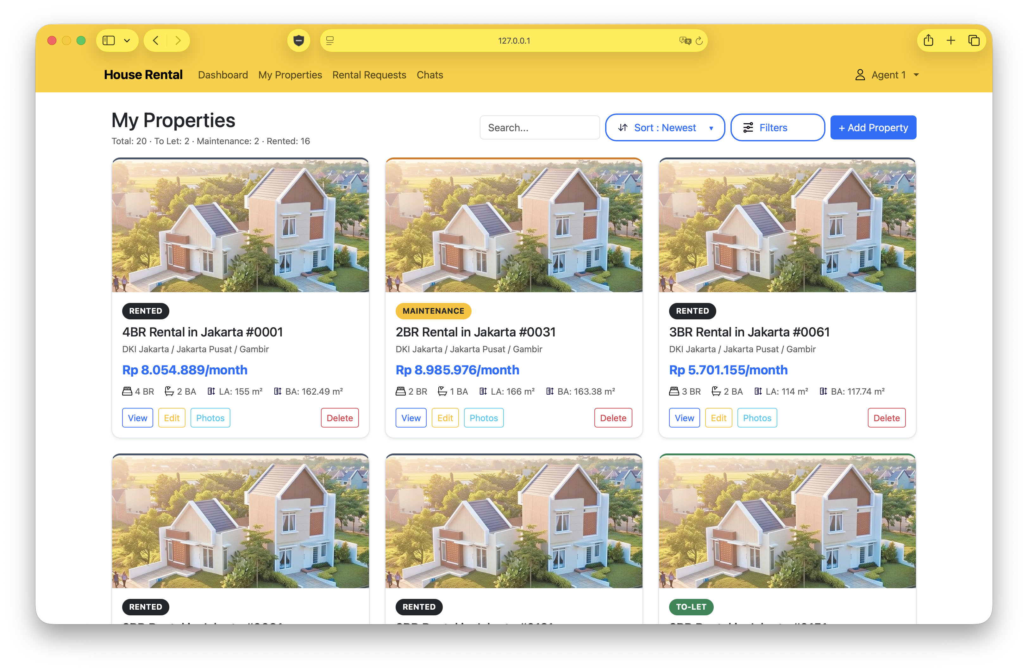
          - My Properties Interface for Agents
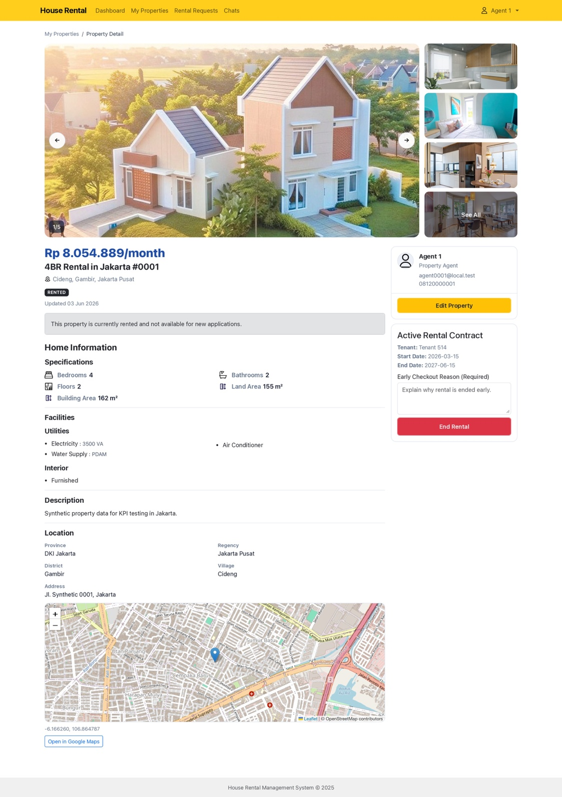
          - Property Details Interface for Agents

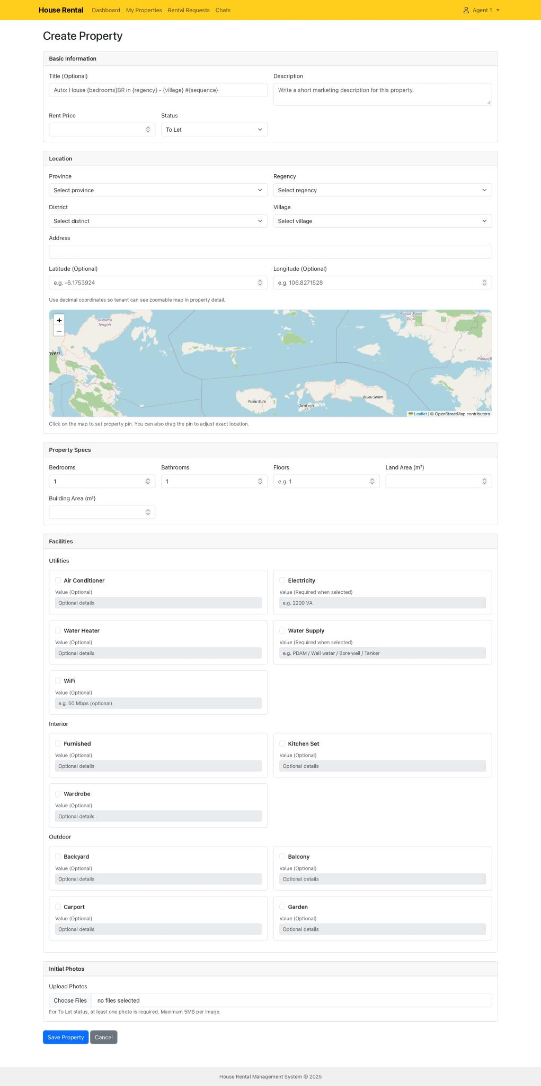
          - Add/Edit Property

    - Rental Request and Transaction
The rental request module supports the core workflow of tenant-to-agent transaction processing. A tenant can select a property and submit a rental request. The system stores the request with an initial status of pending_review so that the agent can review it later.
Agents can review the request and decide whether to approve or reject it. If the request is approved, the system updates the request status to awaiting_payment and calculates the payment due date. If the tenant confirms payment before the due date, the system updates the request to paid and activates the rental transaction. If the payment deadline is missed, the request is automatically marked as cancelled_lost.
The module also supports request cancellation by the tenant or agent when required. These status transitions ensure that the rental workflow remains consistent and that each request follows a controlled lifecycle from submission to completion or cancellation.

    - Contract and Extension
After a payment is successfully confirmed, the system generates or activates the related contract record. The tenant can view and download the contract through the application, while the agent can monitor contract records linked to active rental transactions.
The system also supports contract extension. When a tenant requests an extension, the system creates an extension record and stores it with a pending status. The agent can approve or reject the extension, and the system updates the extension workflow accordingly. If the extension is approved, the payment deadline and contract timeline are adjusted based on the new rental period. The tenant may also cancel an extension request before it is completed.
    - Messaging
The messaging module provides contextual communication between tenants and agents. The system supports conversation-based messaging so that messages can be linked to a property or rental request when needed. This makes the discussion history traceable and easier to manage during the rental process.
The module allows users to send and receive messages, view conversation history, and continue communication within the relevant context. By storing conversation and message records in relational tables, the system keeps communication organized and related to the corresponding rental activity.
    - Profile Management
The profile management module allows authenticated users to update their personal information and change their password. This module helps users maintain accurate account data without needing administrative intervention.
The system validates profile input before saving changes. If the data is valid, the system updates the profile information and keeps the account details synchronized with the latest user input. This module is available to tenants, agents, and admins according to their authenticated access.
    - Admin Monitoring
The admin monitoring module provides visibility over system usage and platform activities. Admin users can monitor user records, view transaction records, and access login audit records. This functionality is intended to support operational supervision and improve accountability across the system.
The login audit records are stored whenever a user logs in successfully. These records include the logged-in user, IP address, browser or device information, and login timestamp. By reviewing these records, the admin can trace access activity and monitor user authentication history.
    - Logout Function
The logout function allows authenticated users to end their session securely. When a user clicks logout, the system invalidates the current session, clears the authentication state, and redirects the user to the login page. This prevents unauthorized reuse of the active session.
  - System Testing
System testing is performed to verify that the implemented functions behave according to the expected requirements. The testing in this study focuses on functional correctness, workflow consistency, and role-based access control.
    - Functional Testing
Functional testing is used to verify that each module produces the expected output for the given input or action. The test cases cover login, property browsing, rental request submission, request approval, payment confirmation, contract viewing, extension handling, messaging, profile updates, logout, user monitoring, transaction monitoring, and login audit monitoring.
    - Workflow Testing
Workflow testing is used to evaluate the end-to-end rental process from property selection to contract activation or cancellation. This includes scenarios where requests are approved, rejected, cancelled, paid on time, or expired due to missed payment deadlines.
    - Access Control Testing
Access control testing is used to verify that tenants, agents, and admins can only access the modules assigned to their roles. This ensures that unauthorized access to protected pages is prevented by the system middleware and role checks.
  - Chapter Summary
This chapter presented the implementation of the core modules of the House Rental Management System and the testing approach used to verify the system behavior. The implemented modules show how the rental workflow, contract handling, messaging, profile management, and administrative monitoring are realized in the Laravel-based application. The next chapter discusses the results and interpretation of the implemented system.
- Chapter 6 Results and Discussion

Conclusion and Suggestion

Appendix Ⅰ Title

References
- Le, H. T., Shar, L. K., Bianculli, D., Briand, L. C., & Nguyen, C. D. (2022). Automated reverse engineering of role-based access control policies of web applications. Journal of Systems and Software, 184, 111109. https://doi.org/10.1016/j.jss.2021.111109
- Monteverde, A. L., Maderazo, J. J. S., Cruz, K. C. M., & Magnaye, N. A. (2023). Web-based rental house smart finder using rapid application development basis for evaluation of ISO 205010. International Journal of Metaverse, 1(1), 1-4. https://doi.org/10.54536/ijm.v1i1.1464
- Obse, Z. G. (2025). Addis Ababa online home rental management system, Ethiopia. Journal of Electrical Systems and Information Technology, 12(1). https://doi.org/10.1186/s43067-025-00220-1
- Setiawan, A. B., Yuniar, E., Hermansyah, M., Mujiono, M., & Ariyadi, D. J. (2026). Decision support system for selecting the best rental house with Weight Product in Sidokare District, Sidoarjo Regency. G-Tech: Jurnal Teknologi Terapan, 10(1), 536-548. https://doi.org/10.70609/g-tech.v10i1.8865
- Wahab, Z. D., Hendryadi, D., & Halik, S. A. (2025). House rental information system at Bulukumba Regency with website based. Journal Informatika, Multimedia, and Infomation, 3(1), 1-11. https://doi.org/10.61912/lajutek.v3i1.129
- Indrayani, S., & Istikomah, S. (2026). Integrated web-based platform for boarding house rental services: Information architecture and booking workflow design. bit-Tech, 8(3), 3834-3845. https://doi.org/10.32877/bt.v8i3.3722
- Muharam, A. S., Solihin, S., Retnaldi, E., Rahmawati, E., & Emalia, L. (2024). Website-based boarding house rental information system: Case study at Pondok Saluyu Company. Journal of Economics, Management, and Entrepreneurship, 2(2), 146-163. https://doi.org/10.55208/jeme.v2i2.174
- Pritalia, G. L., Darren, O., & Wibisono, P. (2025). Understanding user adoption of Indonesia’s boarding house rental app through the extended technology acceptance model. Jurnal Teknologi Sistem Informasi dan Aplikasi, 8(3), 160-169. https://doi.org/10.32493/jtsi.v8i3.44988
- Riyanti, A., Taryana, T., Dirgantoro, G. P., & Gunawan, I. M. A. O. (2024). Development of rental application using prototyping method. TECHNOVATE: Journal of Information Technology and Strategic Innovation Management, 1(2), 69-80. https://doi.org/10.52432/technovate.1.2.2024.69-80
- Rogers, D., Maalsen, S., Wolifson, P., & Fields, D. (2024). Proptech and the private rental sector: New forms of extraction at the intersection of rental properties and platform rentierisation. Urban Studies, 61(14), 2778-2794. https://doi.org/10.1177/00420980241262916
- Şenyüzlüler, F., & Baykasoglu, A. (2024). Development of web based data-driven recommendation system for house rental via hierarchical fuzzy axiomatic design. Kybernetes, 55(2), 1156-1182. https://doi.org/10.1108/k-08-2024-2211
- Upadhyay, A., Shaikh, A., Jane, K., Chaudhari, M., & Shahu, K. (2025). RentEase: An intuitive rental management platform. International Journal on Science and Technology, 16(2). https://doi.org/10.71097/ijsat.v16.i2.5128
- Wainwright, T. (2022). Rental proptech platforms: Changing landlord and tenant power relations in the UK private rental sector? Environment and Planning A: Economy and Space, 55(2), 339-358. https://doi.org/10.1177/0308518x221126522
- Wang, Y., Livingston, M., McArthur, D. P., & Bailey, N. (2024). Enhancing our understanding of short-term rental activity: A daily scrape-based approach for Airbnb listings. PLOS ONE, 19(2), e0298131. https://doi.org/10.1371/journal.pone.0298131
- Wang, J., Cheung, K. L., & Ha, A. Y. (2026). Apparel retail and rental business models and their sustainability implications. Production and Operations Management. https://doi.org/10.1177/10591478261444827
- Salim, A., Sudin, S., Muhammad, N., Duwila, F., & Polulu, F. (2026). Development of a web-based motorcycle rental application with real-time status and digital financial recording. Ambidextrous Journal of Innovation Efficiency and Technology in Organization, 3(1), 134-146. https://doi.org/10.61536/ambidextrous.v3i01.422

Acknowledgements
I would first like to thank my thesis supervisor Professor HAN ZHIREN of the College of Aeronautical Engineering at Shenyang Aerospace University.
I would also like to thank the experts who were involved in the validation survey for this research project: Without their passionate participation and input, the validation survey could not have been successfully conducted...........................(can add more).

版权授权说明
COPYRIGHT AUTHORIZATION DECLARATION
本人授权学校“有权保留送交学位论文的原件，允许学位论文被查阅和借阅，学校可以公布学位论文的全部或部分内容，可以影印、缩印或其他复制手段保存学位论文”；愿意将本人学位论文电子版提交给学校指定授权单位收录和使用。学校必须严格按照授权对论文进行处理，不得超越授权对毕业论文进行任意处置。
I hereby authorize Shenyang Aerospace University the right to retain the original copy of the submitted thesis, allow the thesis to be viewed and borrowed, and the university may publish all or part of the content of the thesis. The thesis may be preserved through photocopying, reduction, or other means of reproduction; I am willing to submit the softcopy of my thesis to the designated authorized unit from the university for indexing and using. The university must strictly handle the thesis in accordance with the authorization.

论文作者签名: 日期：
Candidate’s Signature Date

